Virtual NIC (vNIC)

💻 What is a Virtual NIC (vNIC)?
# Source: Chatgpt (GPT‑5 Mini) at [12/18/2025]
A Virtual NIC (vNIC) is a software-defined network interface that acts like a physical NIC but exists only inside a virtualized environment (like a virtual machine, container, or cloud instance). It allows the virtual system to send and receive data over a network just like a physical device.
✅ A vNIC is a virtual adapter that gives a virtual machine (VM) or container its own network presence, including an IP address and MAC address.

🧱 Where It’s Used
# Source: Chatgpt (GPT‑5 Mini) at [12/18/2025]
- 🖥️ Virtual Machines (e.g., VMware, VirtualBox, KVM, Hyper-V)
- ☁️ Cloud Instances (e.g., AWS EC2, Azure VM)
- 🧩 Containers (e.g., Docker with bridge or overlay networks)
- 🧠 Virtual Network Functions (VNFs, SDN environments)

🔧 Key Features of vNICs
# Source: Chatgpt (GPT‑5 Mini) at [12/18/2025]
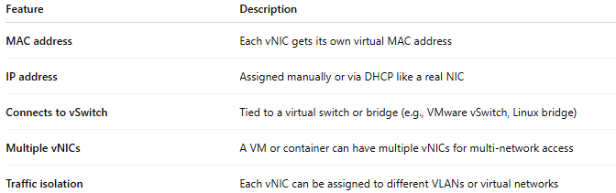

Feature | Description
MAC address | Each vNIC gets its own virtual MAC address
IP address | Assigned manually or via DHCP like a real NIC
Connects to vSwitch | Tied to a virtual switch or bridge (e.g., VMware vSwitch, Linux bridge)
Multiple vNICs | A VM or container can have multiple vNICs for multi-network access
Traffic isolation | Each vNIC can be assigned to different VLANs or virtual networks

🔁 How a vNIC Works (Simplified Flow)
# Source: Chatgpt (GPT‑5 Mini) at [12/18/2025]
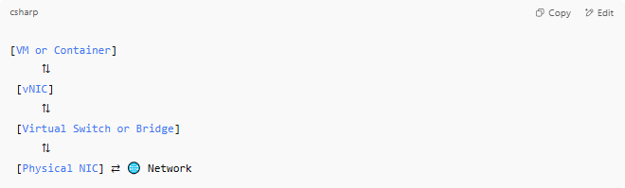
[VM or Container]
⇅
[vNIC]
⇅
[Virtual Switch or Bridge]
⇅
[Physical NIC] ⇄ 🌐 Network

🧠 Example: In a Hypervisor
# Source: Chatgpt (GPT‑5 Mini) at [12/18/2025]
- You spin up a virtual machine
- The hypervisor (e.g., VMware, KVM) creates a vNIC and connects it to a virtual switch
- That switch connects to the host’s physical NIC, allowing the VM to reach the outside network

✅ Advantages
# Source: Chatgpt (GPT‑5 Mini) at [12/18/2025]
- ✅ No extra hardware needed
- ✅ Enables full networking in virtual environments
- ✅ Flexible — can create, delete, or reconfigure vNICs dynamically
- ✅ Can be tied to firewalls, VLANs, QoS, etc.
- ✅ Supports virtual LANs and isolated networks in the same host

❌ Disadvantages
# Source: Chatgpt (GPT‑5 Mini) at [12/18/2025]
- ❌ Depends on host performance and configuration
- ❌ More complex networking setup than physical NICs
- ❌ Improper config may cause IP conflicts or security gaps

📌 Summary
# Source: Chatgpt (GPT‑5 Mini) at [12/18/2025]
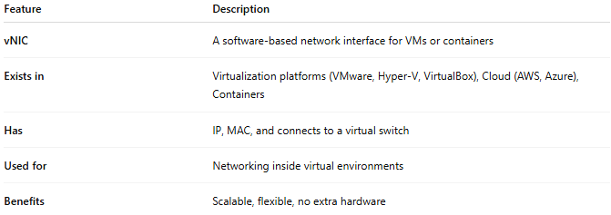
Feature | Description
vNIC | A software-based network interface for VMs or containers
Exists in | Virtualization platforms (VMware, Hyper-V, VirtualBox), Cloud (AWS, Azure), Containers
Has | IP, MAC, and connects to a virtual switch
Used for | Networking inside virtual environments
Benefits | Scalable, flexible, no extra hardware

